**The 5 leading small language models of 2024: Phi 3, Llama 3, and more**

<https://datasciencedojo.com/blog/small-language-models-phi-3/>

**Summary**

The article discusses the emergence and growing importance of Small Language Models (SLMs) in 2024, highlighting five leading models: Phi 3 by Microsoft, Llama 3 by Meta, Mixtral 8x7B by Mistral AI, Gemma by Google, and OpenELM by Apple. These models offer advanced AI capabilities while requiring significantly fewer computational resources than Large Language Models (LLMs) like GPT-3 and BERT. The shift towards SLMs is driven by the need for accessibility, cost-effectiveness, and the democratization of AI technology.

**Introduction**

* **Rise of Small Language Models (SLMs):** While LLMs have dominated the AI landscape due to their impressive capabilities, SLMs are gaining traction for offering similar benefits with reduced computational demands.
* **Need for SLMs:**
  + **Accessibility:** Lower hardware requirements make SLMs accessible to startups, researchers, and businesses without extensive resources.
  + **Cost-Effectiveness:** Reduced energy consumption and hardware costs.
  + **Democratization of AI:** Easier integration across various platforms and applications.

**Benefits of Small Language Models**

* **Reduced Computational Demands:** Require less hardware and energy.
* **Faster Deployment:** Quicker to integrate into existing systems.
* **Adaptability:** Easier to fine-tune and integrate into niche applications.
* **Cost-Effective:** Lower development and operational costs make AI technology accessible to a broader audience.

**How SLMs Excel with Fewer Parameters**

* **Advanced Training Techniques:**
  + **Transfer Learning:** Builds on pre-existing knowledge bases to enhance adaptability.
  + **Knowledge Distillation:** Transfers knowledge from LLMs to SLMs, achieving comparable performance with fewer resources.
* **Focus on Niche Applications:**
  + **Targeted Datasets:** Training on specialized datasets enhances effectiveness in specific contexts.
  + **Customization:** Tailored for specific functions or industries, improving performance in those areas.
* **Efficient Architecture:**
  + **Sparse Mixture of Experts (SMoE):** Optimizes resource usage by engaging specific model segments for tasks.

**Leading Small Language Models of 2024**

**1. Llama 3 by Meta**

* **Overview:**
  + An open-source language model developed by Meta (formerly Facebook).
  + Part of Meta's strategy to promote responsible and widespread AI usage.
* **Performance and Innovation:**
  + **Advanced Training Methods:** Incorporates architecture optimizations.
  + **Large Dataset Training:** Utilizes custom GPU clusters for efficient data processing.
  + **Enhanced Capabilities:** Improved language nuance understanding and multi-step reasoning.
  + **Tasks:** Translation, dialogue generation, complex reasoning.
* **Significance:**
  + **Accessibility and Versatility:** Democratizes access to advanced AI technology.
  + **Instruction-Tuned:** Allows developers to fine-tune the model for specific applications.
  + **Open-Source:** Encourages community collaboration and innovation.

**2. Phi 3 by Microsoft**

* **Overview:**
  + A series of SLMs emphasizing high capability and cost-efficiency.
  + Developed under Microsoft's open AI initiative for public accessibility.
* **Performance and Significance:**
  + **Phi-3-mini:** A 3.8 billion parameter model capable of handling up to 128,000 tokens.
  + **Surpassing Larger Models:** Outperforms similar and larger models in language processing, coding, and mathematical reasoning.
  + **Optimized Deployment:** Supports GPUs, CPUs, and mobile platforms.
  + **Integration:** Compatible with Microsoft technologies like ONNX Runtime and Windows DirectML.
* **AI Safety and Ethics:**
  + **Responsible AI Standard:** Aligns with Microsoft's principles of fairness, transparency, and security.
  + **Trustworthy Tools:** Designed for safe and ethical AI deployment.

**3. Mixtral 8x7B by Mistral AI**

* **Overview:**
  + A Sparse Mixture of Experts (SMoE) model focusing on performance efficiency and accessibility.
  + Developed by Mistral AI with an emphasis on open-source collaboration.
* **Performance and Innovations:**
  + **Efficient Architecture:** Uses a router network to engage different "experts" for tasks.
  + **Resource Optimization:** Total of 46.7 billion parameters but effectively uses about 12.9 billion per token.
  + **Capabilities:**
    - Processes contexts up to 32,000 tokens.
    - Supports multiple languages (English, French, Italian, German, Spanish).
    - Excels in code generation and instruction following.
  + **Benchmark Achievements:** High scores on MT-Bench.
* **Significance:**
  + **Open-Source Licensing:** Apache 2.0 license encourages widespread use and adaptation.
  + **Sustainable AI Practices:** Reduces energy and computational costs.
  + **Collaborative Development:** Fosters transparent AI innovation.

**4. Gemma by Google**

* **Overview:**
  + A new generation of open models designed with responsible AI development in mind.
  + Developed by Google DeepMind and other Google teams.
* **Technical Details and Availability:**
  + **Lightweight and State-of-the-Art:** Functional across various computing environments.
  + **Versions Released:**
    - 2 billion parameter model.
    - 7 billion parameter model.
  + **Variants:** Both pre-trained and instruction-tuned.
  + **Freely Available:** Supports innovation and responsible usage.
* **Significance:**
  + **Democratizing AI Technology:** Enables global developers and researchers to build advanced applications without high costs.
  + **Adaptability:** Models can be fine-tuned for specialized tasks, enhancing efficiency.

**5. OpenELM Family by Apple**

* **Overview:**
  + A family of SLMs developed by Apple, focusing on resource efficiency.
  + Open-source models that can be modified by the research community.
* **Performance and Capabilities:**
  + **Moderate Accuracy:** Achieves acceptable performance on various benchmarks.
  + **Resource Efficiency:** Designed for applications where computational resources are limited.
* **Significance:**
  + **Integration into Hardware Ecosystem:** Embeds AI into Apple's devices like laptops and smartphones.
  + **Enhanced Functionality:** Improves performance in areas with poor connectivity.
  + **Privacy and Security:**
    - On-Device Processing: Minimizes data exposure over networks.
    - Meets Consumer Demands: Aligns with increasing concerns over data privacy.
* **Competitive Advantage:**
  + **Smart Devices:** Enables devices to handle complex AI tasks independently.
  + **User Experience:** Offers responsive and personalized AI interactions.
  + **Industry Impact:** Sets new standards for privacy and functionality in AI.

**The Future of Small Language Models**

* **Efficiency and Integration:**
  + AI development is shifting towards more efficient models that can be integrated directly into devices.
  + SLMs offer powerful AI capabilities without the need for constant cloud connectivity.
* **Enhanced User Experience:**
  + Embedding AI into devices enhances functionality and responsiveness.
  + Upholds privacy standards by processing data locally.
* **Industry Paradigm Shift:**
  + Companies embedding AI into everyday devices set new competitive standards.
  + SLMs enable broader adoption of AI technology across various industries.
* **Privacy and Data Security:**
  + Local processing reduces the risk of data breaches.
  + Appeals to privacy-conscious consumers.

**Conclusion**

Small Language Models are redefining the AI landscape by offering advanced capabilities with reduced computational demands. The leading models of 2024—Phi 3, Llama 3, Mixtral 8x7B, Gemma, and OpenELM—demonstrate how SLMs are making AI technology more accessible, cost-effective, and adaptable. These models enable startups, researchers, and businesses to leverage AI without the extensive resources typically required by Large Language Models.

**Key Takeaways:**

* **Accessibility and Democratization:** SLMs lower the barrier to entry for AI development and deployment.
* **Cost-Effectiveness:** Reduced energy consumption and hardware requirements make SLMs economically viable.
* **Adaptability:** Fine-tuning for specific tasks enhances performance in niche applications.
* **Privacy and Security:** On-device processing aligns with consumer demands for data privacy.
* **Industry Impact:** Embedding SLMs into devices sets new standards for AI integration and functionality.

By focusing on efficiency, integration, and responsible AI practices, Small Language Models are poised to play a pivotal role in the future of artificial intelligence, driving innovation while respecting privacy and resource constraints.

**Full article**

Join Discord Community

In recent years, the landscape of artificial intelligence has been transformed by the development of large language models like GPT-3 and BERT, renowned for their impressive capabilities and wide-ranging applications.

However, alongside these giants, a new category of AI tools is making waves—the small language models (SLMs). These models, such as LLaMA 3, Phi 3, Mistral 7B, and Gemma, offer a potent combination of advanced AI capabilities with significantly reduced computational demands.

**Why are Small Language Models Needed?**

This shift towards smaller, more efficient models is driven by the need for accessibility, cost-effectiveness, and the democratization of AI technology.

Small language models require less hardware, lower energy consumption, and offer faster deployment, making them ideal for startups, academic researchers, and businesses that do not possess the immense resources often associated with big tech companies.

Moreover, their size does not merely signify a reduction in scale but also an increase in adaptability and ease of integration across various platforms and applications.

[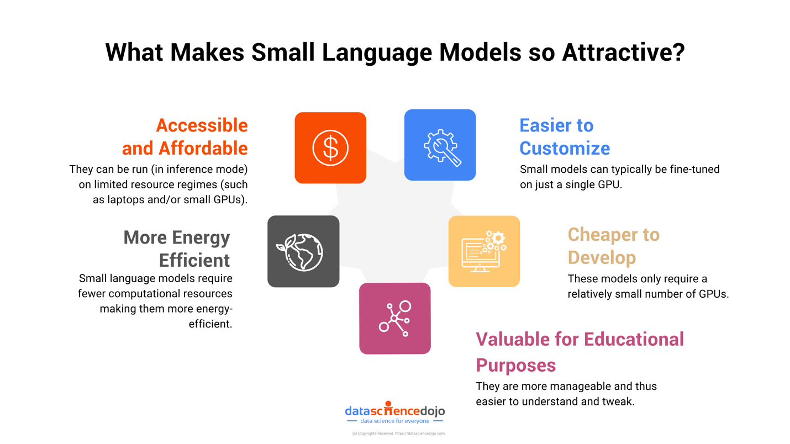](https://datasciencedojo.com/blog/small-language-models-slms/)

**How Small Language Models Excel with Fewer Parameters?**

Several factors explain why smaller language models can perform effectively with fewer parameters.

Primarily, advanced training techniques play a crucial role. Methods like transfer learning enable these models to build on pre-existing knowledge bases, enhancing their adaptability and efficiency for specialized tasks.

For example, knowledge distillation from large language models to small language models can achieve comparable performance while significantly reducing the need for computational power.

Moreover, smaller models often focus on niche applications. By concentrating their training on targeted datasets, these models are custom-built for specific functions or industries, enhancing their effectiveness in those particular contexts.

For instance, a small language model trained exclusively on medical data could potentially surpass a general-purpose large model in understanding medical jargon and delivering accurate diagnoses.

However, it’s important to note that the success of a small language model depends heavily on its training regimen, fine-tuning, and the specific tasks it is designed to perform. Therefore, while small models may excel in certain areas, they might not always be the optimal choice for every situation.

**Best Small Langauge Models in 2024**

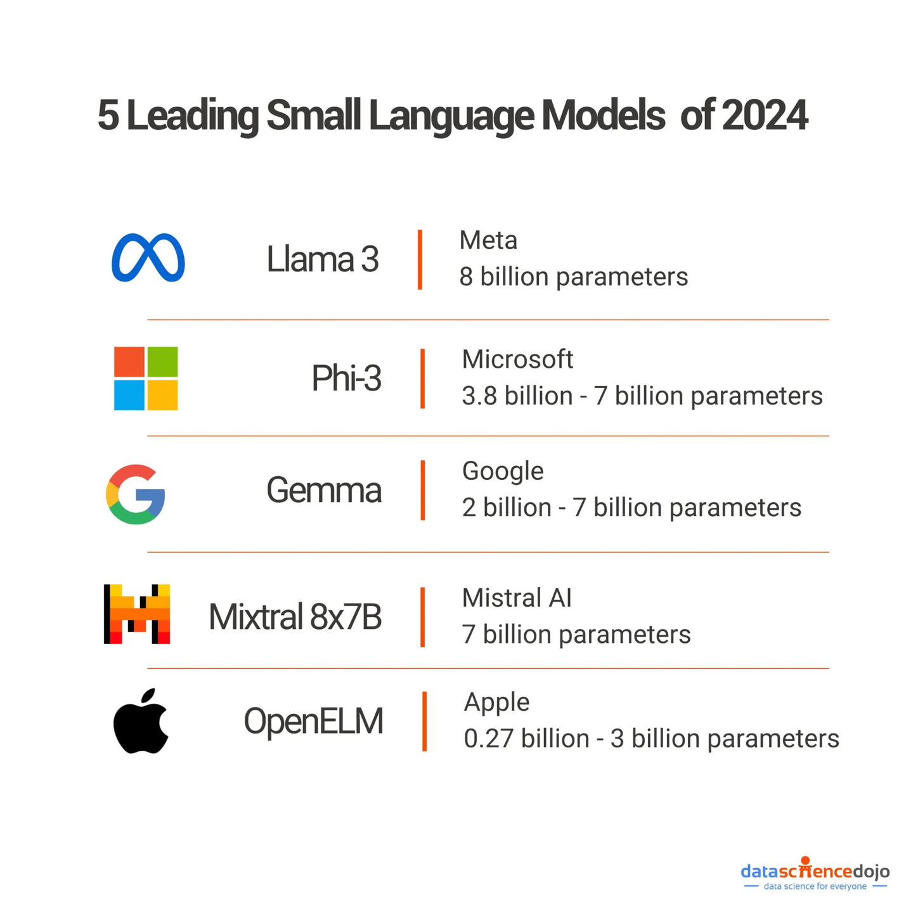Leading Small Language Models (SLMs)

**1. Llama 3 by Meta**

LLaMA 3 is an [open-source](https://datasciencedojo.com/blog/open-source-llms-for-enterprises-benefits/) language model developed by Meta. It’s part of Meta’s broader strategy to empower more extensive and responsible AI usage by providing the community with tools that are both powerful and adaptable. This model builds upon the success of its predecessors by incorporating advanced training methods and architecture optimizations that enhance its performance across various tasks such as translation, dialogue generation, and complex reasoning.

**Performance and Innovation**

Meta’s LLaMA 3 has been trained on significantly larger datasets compared to earlier versions, utilizing custom-built GPU clusters that enable it to process vast amounts of data efficiently.

This extensive training has equipped LLaMA 3 with an improved understanding of language nuances and the ability to handle multi-step reasoning tasks more effectively. The model is particularly noted for its enhanced capabilities in generating more aligned and diverse responses, making it a robust tool for developers aiming to create sophisticated AI-driven applications.

[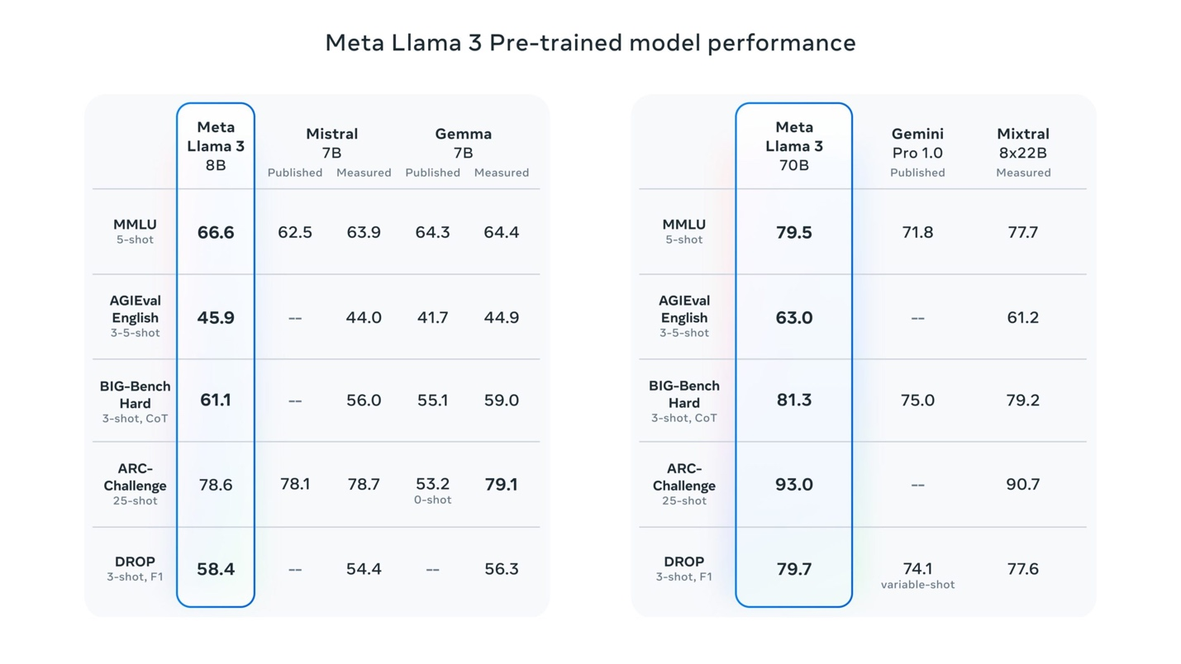](https://datasciencedojo.com/blog/exploring-llama-3-the-new-llm/)Llama 3 pre-trained model performance – Source: Meta

**Why LLaMA 3 Matters**

The significance of LLaMA 3 lies in its accessibility and versatility. Being open-source, it democratizes access to state-of-the-art AI technology, allowing a broader range of users to experiment and develop applications. This model is crucial for promoting innovation in AI, providing a platform that supports both foundational and advanced AI research. By offering an instruction-tuned version of the model, Meta ensures that developers can fine-tune LLaMA 3 to specific applications, enhancing both performance and relevance to particular domains.

***Learn more about Meta’s***[***Llama 3***](https://datasciencedojo.com/blog/exploring-llama-3-the-new-llm/)

**2. Phi 3 By Microsoft**

Phi-3 is a pioneering series of SLMs developed by Microsoft, emphasizing high capability and cost-efficiency. As part of Microsoft’s ongoing commitment to accessible AI, Phi-3 models are designed to provide powerful AI solutions that are not only advanced but also more affordable and efficient for a wide range of applications.

These models are part of an open AI initiative, meaning they are accessible to the public and can be integrated and deployed in various environments, from cloud-based platforms like Microsoft Azure AI Studio to local setups on personal computing devices.

**Performance and Significance**

The Phi 3 models stand out for their exceptional performance, surpassing both similar and larger-sized models in tasks involving language processing, coding, and mathematical reasoning.

Notably, the Phi-3-mini, a 3.8 billion parameter model within this family, is available in versions that handle up to 128,000 tokens of context—setting a new standard for flexibility in processing extensive text data with minimal quality compromise.

Microsoft has optimized Phi 3 for diverse computing environments, supporting deployment across GPUs, CPUs, and mobile platforms, which is a testament to its versatility.

Additionally, these models integrate seamlessly with other Microsoft technologies, such as ONNX Runtime for performance optimization and Windows DirectML for broad compatibility across Windows devices.

[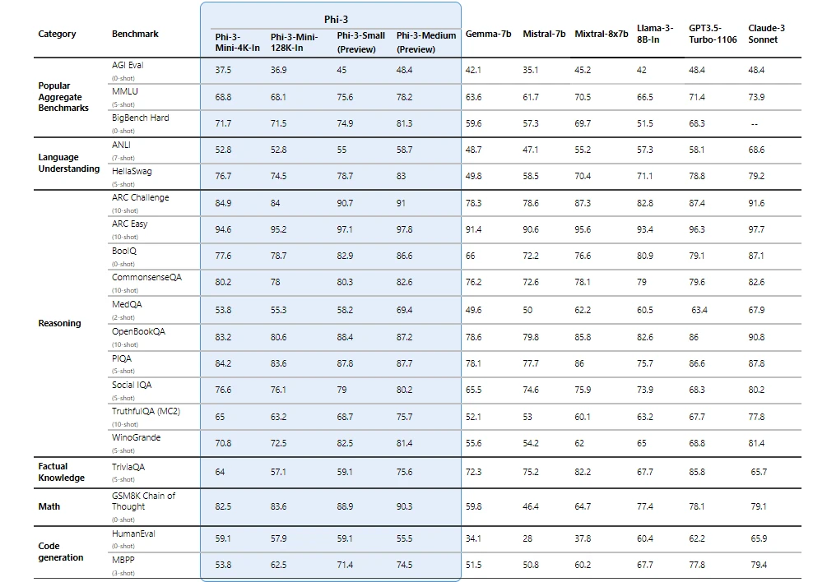](https://azure.microsoft.com/en-us/blog/introducing-phi-3-redefining-whats-possible-with-slms/)Phi-3 family comparison with Gemma 7b, Mistral 7b, Mixtral 8x7b, Llama 3 – Source: Microsoft

**Why Does Phi 3 Matter?**

The development of Phi 3 reflects a significant advancement in AI safety and ethical AI deployment. Microsoft has aligned the development of these models with its Responsible AI Standard, ensuring that they adhere to principles of fairness, transparency, and security, making them not just powerful but also trustworthy tools for developers.

**3. Mixtral 8x7B by Mistral AI**

[Mixtral](https://datasciencedojo.com/blog/mixtral-of-experts-by-mistral-ai/), developed by Mistral AI, is a groundbreaking model known as a Sparse Mixture of Experts (SMoE). It represents a significant shift in AI model architecture by focusing on both performance efficiency and open accessibility.

[Mistral AI](https://datasciencedojo.com/blog/mistral-7b-emergence-in-llm/), known for its foundation in open technology, has designed Mixtral to be a decoder-only model, where a router network selectively engages different groups of parameters, or “experts,” to process data.

This approach not only makes Mixtral highly efficient but also adaptable to a variety of tasks without requiring the computational power typically associated with large models.

***Explore the***[***showdown of 7B LLMs***](https://datasciencedojo.com/blog/mistral-7b-vs-llama-2-7b/)***– Mistral 7B vs Llama-2 7B***

**Performance and Innovations**

Mixtral excels in processing large contexts up to 32k tokens and supports multiple languages including English, French, Italian, German, and Spanish.

It has demonstrated strong capabilities in code generation and can be fine-tuned to follow instructions precisely, achieving high scores on benchmarks like the MT-Bench.

What sets Mixtral apart is its efficiency—despite having a total parameter count of 46.7 billion, it effectively utilizes only about 12.9 billion per token, aligning it with much smaller models in terms of computational cost and speed.

**Why Does Mixtral Matter?**

The significance of Mixtral lies in its open-source nature and its licensing under Apache 2.0, which encourages widespread use and adaptation by the developer community.

This model is not only a technological innovation but also a strategic move to foster more collaborative and transparent AI development. By making high-performance AI more accessible and less resource-intensive, Mixtral is paving the way for broader, more equitable use of advanced AI technologies.

Mixtral’s architecture represents a step towards more sustainable AI practices by reducing the energy and computational costs typically associated with large models. This makes it not only a powerful tool for developers but also a more environmentally conscious choice in the AI landscape.

**4. Gemma by Google**

Gemma is a new generation of open models introduced by Google, designed with the core philosophy of responsible AI development. Developed by Google DeepMind along with other teams at Google, Gemma leverages the foundational research and technology that also gave rise to the Gemini models.

**Technical Details and Availability**

Gemma models are structured to be lightweight and state-of-the-art, ensuring they are accessible and functional across various computing environments—from mobile devices to cloud-based systems.

Google has released two main versions of Gemma: a 2 billion parameter model and a 7 billion parameter model. Each of these comes in both pre-trained and instruction-tuned variants to cater to different developer needs and application scenarios.

Gemma models are freely available and supported by tools that encourage innovation, collaboration, and responsible usage.

**Why Does Gemma Matter?**

Gemma models are significant not just for their technical robustness but for their role in democratizing AI technology. By providing state-of-the-art capabilities in an open model format, Google facilitates a broader adoption and innovation in AI, allowing developers and researchers worldwide to build advanced applications without the high costs typically associated with large models.

Moreover, Gemma models are designed to be adaptable, allowing users to tune them for specialized tasks, which can lead to more efficient and targeted AI solutions

[Explore a hands-on curriculum that helps you build custom LLM applications!](https://cta-redirect.hubspot.com/cta/redirect/3274755/c62d0c07-b654-4942-8a07-e0e647845d73)

**5. OpenELM Family by Apple**

[OpenELM](https://arxiv.org/abs/2404.14619) is a family of small language models developed by Apple. OpenELM models are particularly appealing for applications where resource efficiency is critical. OpenELM is open-source, offering transparency and the opportunity for the wider research community to modify and adapt the models as needed.

**Performance and Capabilities**

Despite their smaller size and open-source nature, it’s important to note that OpenELM models do not necessarily match the top-tier performance of some larger, more closed-source models. They achieve moderate accuracy levels across various benchmarks but may lag behind in more complex or nuanced tasks. For example, while OpenELM shows improved performance compared to similar models like OLMo in terms of accuracy, the improvement is moderate.

**Why Does OpenELM Matter?**

OpenELM represents a strategic move by Apple to integrate state-of-the-art generative AI directly into its hardware ecosystem, including laptops and smartphones.

By embedding these efficient models into devices, Apple can potentially offer enhanced on-device AI capabilities without the need to constantly connect to the cloud.

[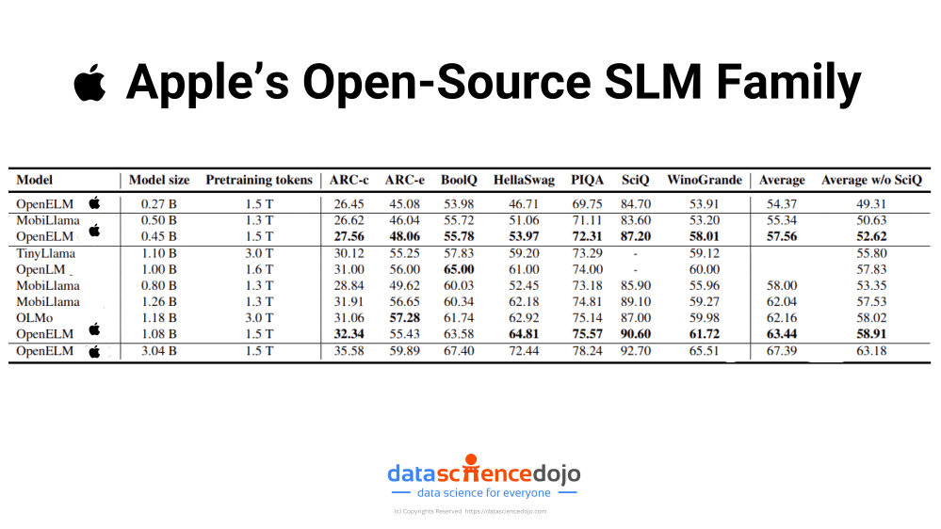](https://machinelearning.apple.com/research/openelm)Apple’s Open-Source SLM family

This not only improves functionality in areas with poor connectivity but also aligns with increasing consumer demands for privacy and data security, as processing data locally minimizes the risk of exposure over networks.

Furthermore, embedding OpenELM into Apple’s products could give the company a significant competitive advantage by making their devices smarter and more capable of handling complex AI tasks independently of the cloud.

This can transform user experiences, offering more responsive and personalized AI interactions directly on their devices. The move could set a new standard for privacy in AI, appealing to privacy-conscious consumers and potentially reshaping consumer expectations in the tech industry.

**The Future of Small Language Models**

As we dive deeper into the capabilities and strategic implementations of small language models, it’s clear that the evolution of AI is leaning heavily towards efficiency and integration. Companies like Apple, Microsoft, and Google are pioneering this shift by embedding advanced AI directly into everyday devices, enhancing user experience while upholding stringent privacy standards.

This approach not only meets the growing consumer demand for powerful, yet private technology solutions but also sets a new paradigm in the competitive landscape of tech companies.